Wigii – Reference manual


→ How to edit the Configuration files

- Before you start editing the Wigii Config files you need to make sure you have two different browsers installed on you computer
Note : You need to be Nadmin to access the General Configuration
It is recommended that you use Mozilla Firefox with Google Chrome or Safari
To install :
- Firefox visit : http://www.mozilla-europe.org/en/firefox/
- Safari visit : http://www.apple.com/safari/
- Chrome visit : http://www.google.com/chrome/?hl=en-GB&hl=de
or read the “How to install Chrome” guide
Note : It is NOT advised to use Internet Explorer with the Wigii system for it 5x slower than the other browsers
IMPORTANT : Using two different browser enables you to modify the Config in one browser, and then check the changes with Firefox to see if they have applied correctly and that they haven’t caused a problem on the Wigii system

- In Firefox you need to install the “Web developer” add-on

- Open Firefox, go into
“Tools → Add-ons”
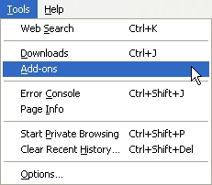

- A new window will open, go in the get Add-ons tab
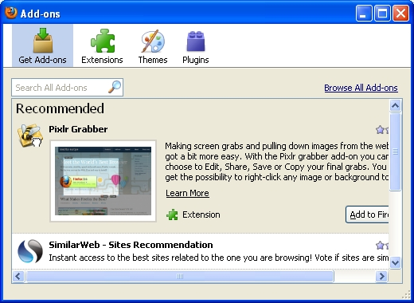

- Search for

- Once you have found it click on the Add to Firefox button
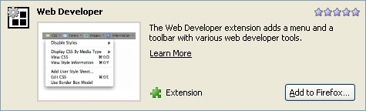

- This warning window will open, click on
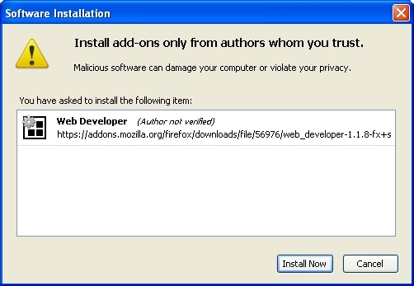

- Once the Add-on has finished downloading you must restart Firefox in order for it to be installed. So click on
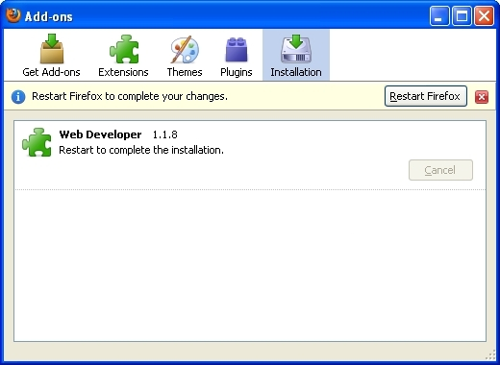

- Once you have restarted Firefox the Add-on will be installed and you will now see an additional Tools bar underneath your bookmarks

IMPORTANT : Explained below is the process you should go through when editing a configuration file

- Open either Chrome or Safari
- Go on the e-library : https://e-library.medair.org/
- Log in, and go in the Name space you wish to edit the Config of
- Click on the “Open admin console”
- Select any Tab and click on General configuration
Note : You need to be Nadmin to access the General Configuration
(The role needs the Edit Config checkbox to be ticked)
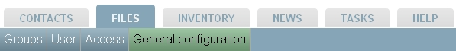


- You will access the configuration window
Select the config.xml document you want to modify and click “Edit”
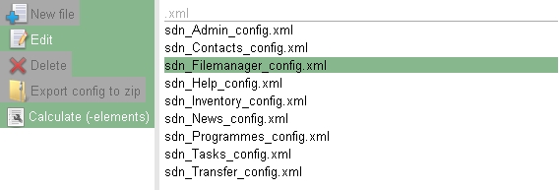

- A new window will open with the Config in .xml format
Note : If the window is empty then the space uses the general Configuration of the system. Ask the SuperAdmin if you want a copy of it
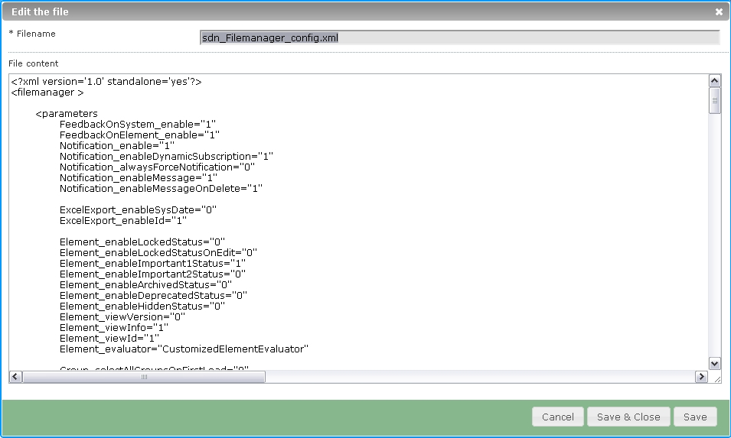

- Copy all the Config (Press CTRL + A then CTRL + C) and paste it (CTRL + V) in a new notepad page. You can use it as a recovery backup in case you do a mistake while modifying the configuration
- Now you can edit the Config directly in your browser
- Or you can use a program such as Programmer’s Notepad
Download the portable version at : http://www.pnotepad.org/
Paste the Config in the program and then you can modify it
Note : This program enables you to have a better view of the Config. Be sure to select the correct file format, in this case XML
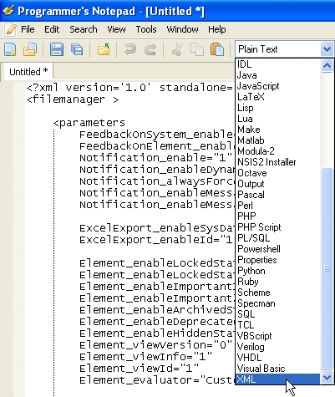

- It will then be much easier to read the Config as the different attributes / values will appear in different colors
Example
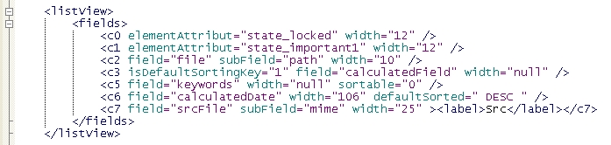

- Once you have done the changes to the Config click
(If using an editor : copy it from your editor and paste it in the Config window in your browser ) Then click Save
- Keep Chrome open and open Firefox as well, then log in the Wigii system
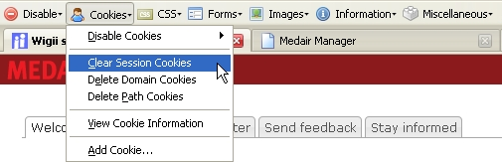
- If Firefox was already open in Wigii you need to clear you session cookies to simulate restarting Firefox. Then you can view the changes
To Clear you session cookies use the Web Developer add-on tool bar you installed earlier and go in “Cookies → Clear Session Cookies “

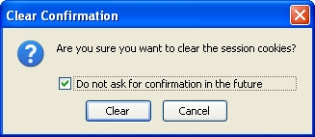
- A new window will ask you if you are sure you want to delete the cookies, click “Clear”

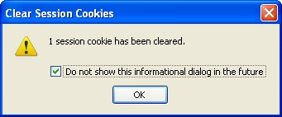
- Then an other window will open and tell you how many cookies have been deleted, click “Ok”

Note : You can tick the checkbox if you do not want to view these pop up windows each time you clear your cookies

- Refresh (Press F5) and then you can look for the changes you did in the Wigii system and check if they were applied correctly
  - If the changes have not applied correctly, change the Config, load it back up on Chrome and save it. Then recheck with Firefox
Note : Be sure to clear your cookies each time you have done changes
  - If the Wigii doesn’t work correctly, reload in Chrome the recovery backup Config that you have previously saved in a Notepad document
  - If the changes applied correctly then you can shut the Config window
- To quit the Admin Console click on the “Close admin
console” button
→ To know more about the Config refer to : How to manage the Config & the Configuration Manual

